**You have to submit this report via Moodle.**

|  |  |  |
| --- | --- | --- |
| Digital Design and Computer Architecture: Lab Report | | |
| Lab 8: Full System Integration (Session II) | | |
| Date | 02.06.2021 | Grade |
| Names | Berner, Zheng |  |
|  |  | Lab session / lab room |
|  |  | Friday 08:15  Zoom breakout room 60 |

**Use a zip file or tarball that contains the report and any other required material. Only one member from each group should submit the report. All members of the group will get the same grade.**

**The name of the submitted file should be *Lab8_LastName1_LastName2.zip* (or *.tar*), where *LastName1* and *LastName2* are the last names of the members of the group.**

**Note 1: Please include all the required material. No links/shortcuts are accepted.**

**Note 2: The deadline for the report is a hard deadline and it will not be extended.**

**Exercise 1**

Below is a part of the MIPS block diagram. Draw the necessary modifications for the memory-mapped I/O on this block diagram. (We are only interested in the SW and LW instructions; the rest of the block diagram has been purposefully left out. *Hint: If your circuit works, you already implemented this in the* MIPS.v *module.)*

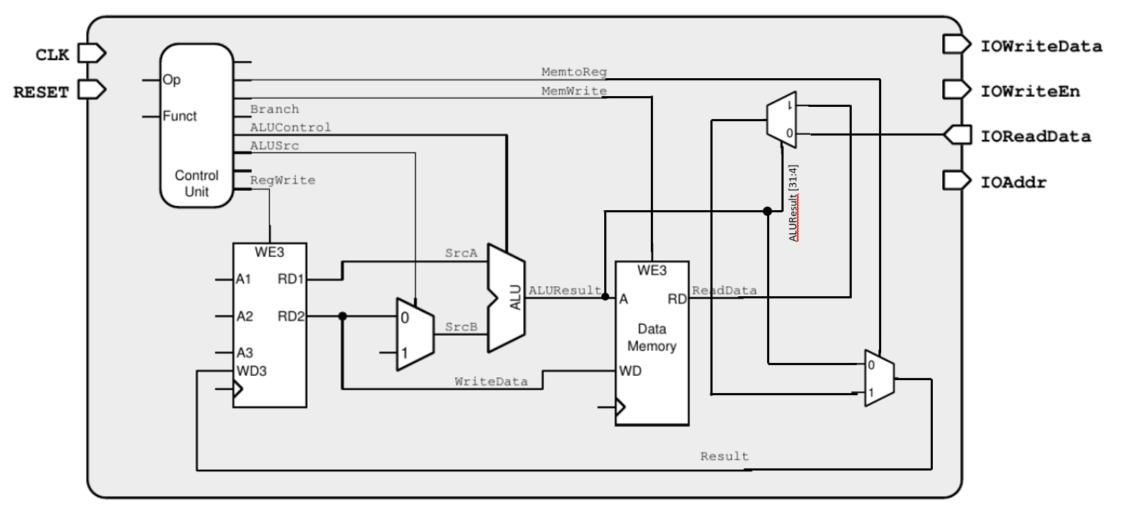

**Exercise 2**

Using Figure 1 as a reference, what additional hardware/architectural changes are needed in the top module (*top.v* file) to implement Challenge 2 described in the Manual of Lab 8, Session 2? You can either draw the additional circuitry required or write in your own words here.

**We need to add an additional MUX to the top module.**

**The MUX has the signal of the speed switch and a 1bit zero (wired to the ground) as its two inputs.**

**The output is written to IOReadData[2].**

**The MUX takes IOAddr as its control signal.**

**If IOAddr is a 4bit eight, the switch signal is passed on. Otherwise, the 1bit zero gets selected.**

**Feedback**

If you have any comments about the exercise, please add them here: mistakes in the text, difficulty level of the exercise, or anything that will help us improve it for the next time.